**1. Review of Entity Framework Core Integration**

Entity Framework (EF) Core is an Object-Relational Mapper (ORM) that enables .NET developers to work with a database using .NET objects, eliminating the need for most data-access code.

In this project, we have used:

* **Database First Approach** – The database is designed first, and EF Core models are generated from it.
* **DbContext Class** – It manages the database connection and mapping between classes and tables.
* **Stored Procedures with EF Core** – EF Core can execute stored procedures using FromSqlRaw() for read operations or ExecuteSqlRaw() for insert, update, and delete operations.

**2. Project Components**

1. **Database:**
   * StudentCourseDB containing two tables:
     + Students – Stores student details
     + Courses – Stores course information
   * Stored procedures:
     + GetAllStudents
     + sp_GetStudentById
     + sp_AddStudent
     + sp_UpdateStudent
     + sp_DeleteStudent
2. **Model Classes (in Models folder):**
   * Student.cs
   * Course.cs
   * These define the data structure in C# that maps to database tables.
3. **DbContext Class (ApplicationDbContext.cs):**
   * Contains DbSet<Student> and DbSet<Course>.
   * Manages database connections and configurations.
4. **Controller (StudentsController.cs):**
   * Contains API endpoints to perform CRUD operations using stored procedures and EF Core.

**3. CRUD Operations with EF Core and Stored Procedures**

**A. Retrieve All Students**

* **Purpose:** To fetch all student records along with their course details.
* **EF Core Code:**

var students = _context.Students.FromSqlRaw("EXEC GetAllStudents").ToList();

* **Key Point:** The stored procedure must return all columns defined in the Student model, including CourseId.

**B. Retrieve Student by ID**

* **Purpose:** To fetch a specific student record based on their ID.
* **EF Core Code:**

var student = _context.Students

.FromSqlRaw("EXEC sp_GetStudentById @Id={0}", id)

.AsEnumerable()

.FirstOrDefault();

**Validation:** Return 404 if the student is not found.

**C. Add a New Student**

* **Purpose:** To insert a new student record into the database.
* **EF Core Code:**

_context.Database.ExecuteSqlRaw(

"EXEC sp_AddStudent @Name={0}, @Age={1}, @Grade={2}, @CourseId={3}",

student.Name, student.Age, student.Grade, student.CourseId

);

**Validation:** Check if all required fields are provided before executing.

**D. Update Student Details**

* **Purpose:** To update an existing student record.
* **EF Core Code:**

_context.Database.ExecuteSqlRaw(

"EXEC sp_UpdateStudent @Id={0}, @Name={1}, @Age={2}, @Grade={3}, @CourseId={4}",

id, student.Name, student.Age, student.Grade, student.CourseId

);

**Validation:** Ensure the student exists before updating.

**E. Delete Student**

* **Purpose:** To delete a student record from the database.
* **EF Core Code:**

_context.Database.ExecuteSqlRaw("EXEC sp_DeleteStudent @Id={0}", id);

**Validation:** Confirm that the record exists before deletion.

**4. Testing the API**

**A. Using Swagger**

1. Run the project (dotnet run).
2. Open Swagger at: http://localhost:<port>/swagger.
3. Test endpoints:
   * GET /api/students – Fetch all students.
   * GET /api/students/{id} – Fetch by ID.
   * POST /api/students – Add new student.
   * PUT /api/students/{id} – Update details.
   * DELETE /api/students/{id} – Delete a record.

**B. Using Postman**

1. Create a new collection for StudentApi.
2. Add requests for all endpoints with proper HTTP methods.
3. Use JSON body in POST and PUT requests like:

{

"name": "John Doe",

"age": 23,

"grade": "A",

"courseId": 2

}

**5. Common Errors and Fixes**

|  |  |  |
| --- | --- | --- |
| **Error** | **Cause** | **Fix** |
| CourseId missing in FromSql | Stored procedure not returning all columns | Include CourseId in SELECT statement |
| Invalid column name | Property name mismatch | Ensure property names match table columns |
| 500 Internal Server Error | Missing validation or incorrect SQL syntax | Check stored procedure parameters and data types |
| Cannot connect to DB | Connection string issue | Verify appsettings.json connection string |

**6. Validation and Best Practices**

* Use **Data Annotations** in model classes for validation (e.g., [Required], [StringLength], [Range]).
* Implement **try-catch blocks** in controllers to handle exceptions gracefully.
* Ensure **stored procedures** have proper error handling using TRY-CATCH in SQL.
* Follow **RESTful conventions** for API routes and responses.
* Always **log errors** in case of failure for debugging.

**8. Mini Exercise**

Build and test all API endpoints:

1. Fetch all students.
2. Fetch student by ID.
3. Add a new student.
4. Update an existing student.
5. Delete a student record.

**Snapshots :**

Database and tables created successfully in SSMS

Stored procedures verified and executed in SSMS (sp_GetStudents)

Project structure shown in Visual Studio

Connection string configured in appsettings.json

ApplicationDbContext class with DbSets for Student and Course

StudentsController implemented with CRUD endpoints

dotnet build completed successfully in terminal

Swagger UI loaded showing all API endpoints

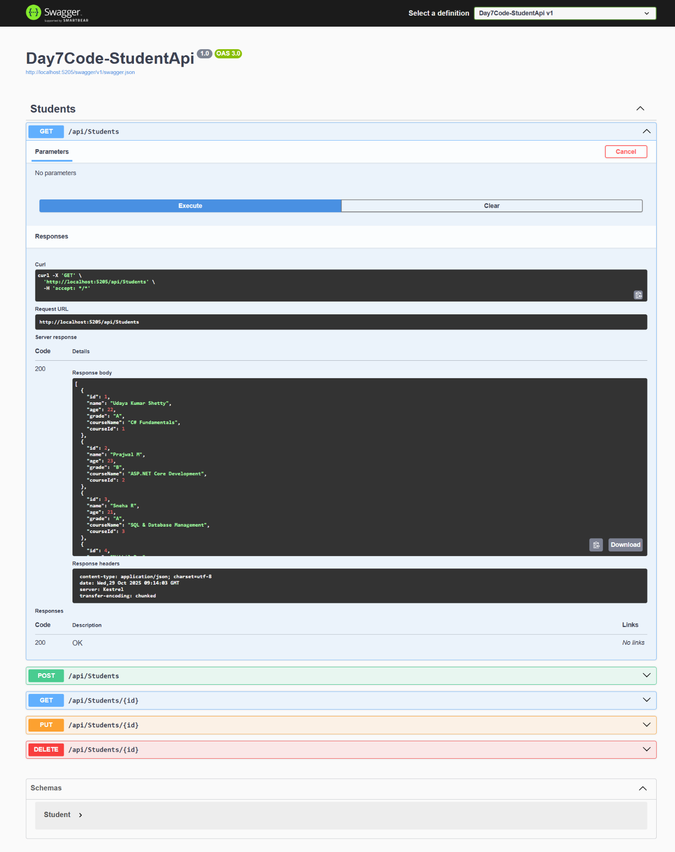

GET /api/students returns full list of students

POST /api/students adds new student successfully

GET /api/students/{id} returns specific student

PUT /api/students/{id} updates record details

DELETE /api/students/{id} removes record from database

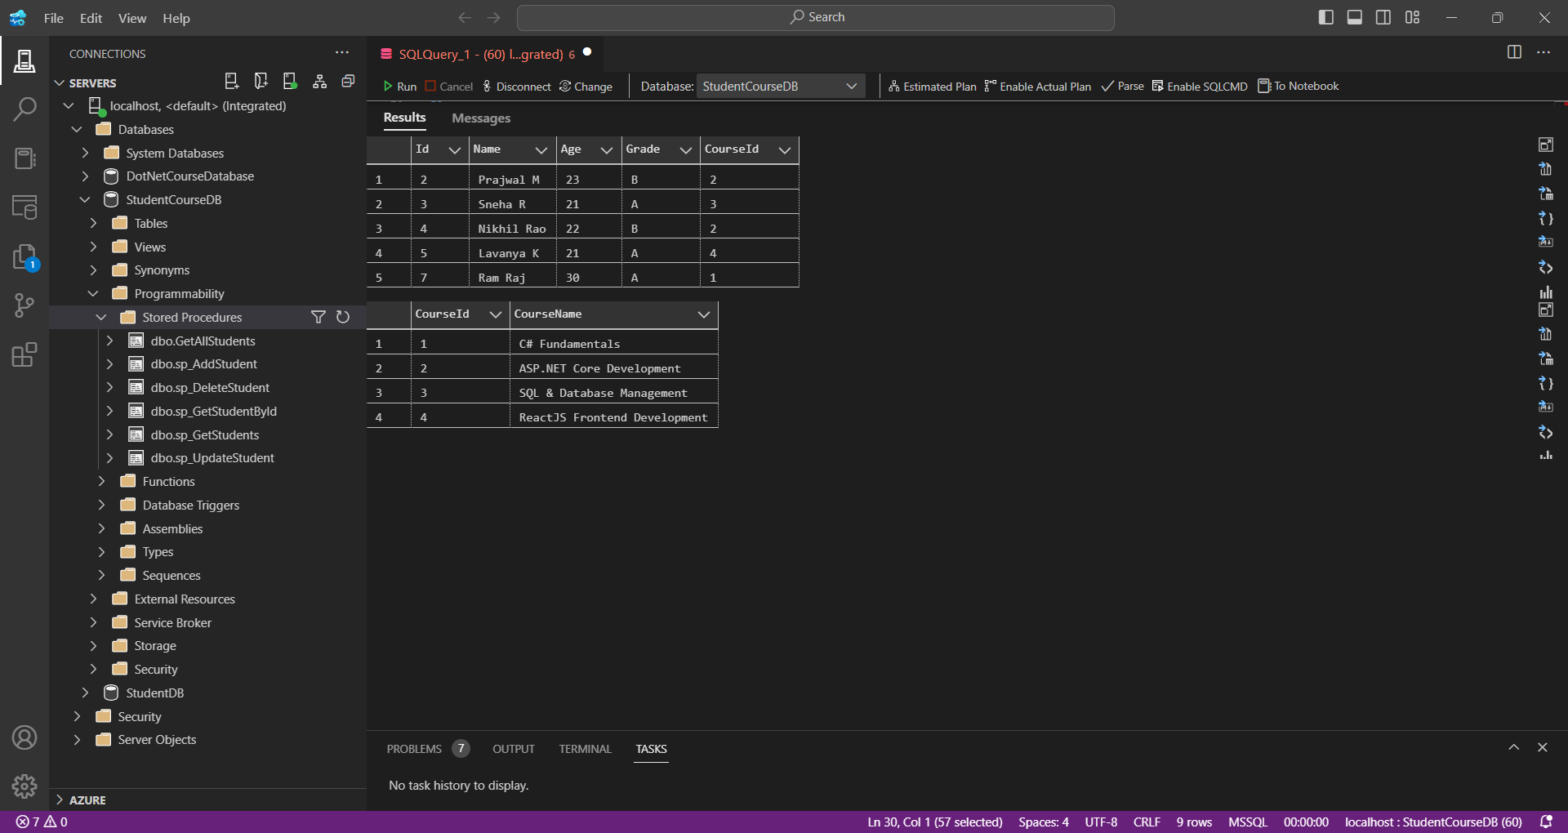

SQL Server view shows updated student and course tables after CRUD operations